**LAB -4**

**TASK -1**

**CODE:**

using System;

using System.Collections.Generic;

using System.Linq;

using System.Text;

namespace oop11

{

public class Student

{

public string name;

public string save

{

get

{

return name;

}

set

{

name = value;

}

}

public static int Main(string[] args)

{

Student st = new Student();

st.name="Ali";

Console.WriteLine("The Student Name is : {0}", st.name);

return 0;

}

}

}

**OUTPUT:**

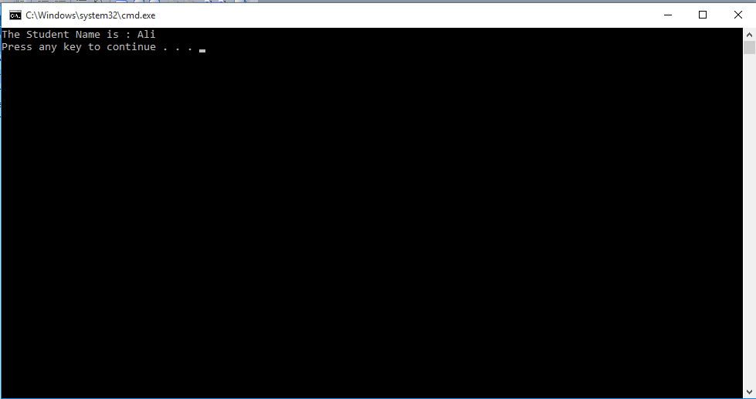

**TASK -2**

**CODE:**

using System;

using System.Collections.Generic;

using System.Linq;

using System.Text;

namespace oop12

{

class maths

{

public static int factorial(int fac, int n)

{

for (int i = 1; i <= n; i++)

{

fac *= i;

}

return fac;

}

static void Main(string[] args)

{

int fac=1;

int n;

Console.WriteLine("Enter any Number for Factorial : ");

n = Convert.ToInt32(Console.ReadLine());

fac=maths.factorial(fac, n);

Console.WriteLine("Factorial : {0}",fac);

}

}

}

**OUTPUT:**

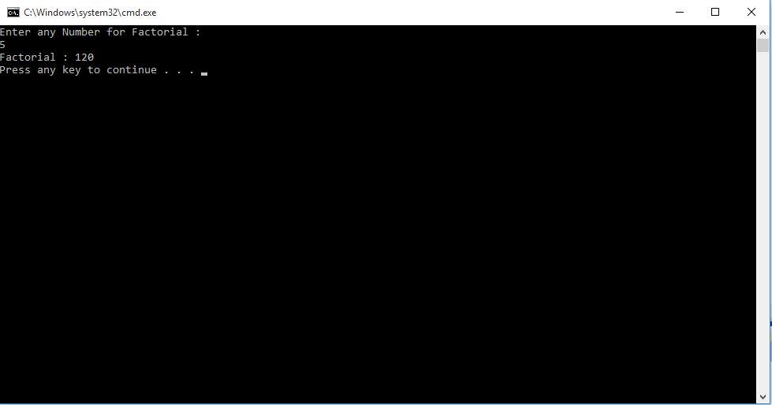

**TASK -3**

**CODE:**

using System;

using System.Collections.Generic;

using System.Linq;

using System.Text;

namespace oop13

{

class vehicle

{

private string honda;

private string toyota;

private string suzuki;

public string getcity()

{

return honda;

}

public void setcity()

{

honda = "city";

}

public string getcorolla()

{

return toyota;

}

public void setcorolla()

{

toyota = "corolla";

}

public string getmehran()

{

return suzuki;

}

public void setmehran()

{

suzuki = "mehran";

}

static void Main(string[] args)

{

vehicle v = new vehicle();

v.setcity();

v.setcorolla();

v.setmehran();

Console.WriteLine(v.getcity());

Console.WriteLine(v.getcorolla());

Console.WriteLine(v.getmehran());

}

}

}

**OUTPUT:**

